Integration Manual
SpecterX Mail Protection Cloud Service: Configuration for Microsoft Purview



Introduction
This guide outlines the configuration steps required to integrate Microsoft Purview’s classification and Data Loss Prevention (DLP) capabilities with the SpecterX Mail Protection Cloud Service. By leveraging Purview’s native classification engine, SpecterX enables automated detection of sensitive data and ensures that classified or policy-violating emails are securely redirected for protection, rather than being quarantined or blocked. This integration allows organizations to maintain compliance, enhance visibility, and ensure that sensitive communications are handled through SpecterX’s secure protection workflows - all without disrupting normal mail flow.

After completing this configuration, Microsoft Purview will identify and tag emails containing sensitive information and route them to SpecterX for protection. This replaces the standard quarantine action with a secure redirection flow managed by SpecterX, ensuring that sensitive emails are handled in accordance with your organization’s protection policies. The result is a unified solution that combines Purview’s intelligent classification with SpecterX’s real-time security and audit capabilities to deliver seamless, compliant email protection.
⚠️ Note: Please consult with your IT or system administrator before proceeding if this configuration may impact other managed extensions or browser settings.

Microsoft Exchange Online

Create SpecterX Mail Protection Service Contact
- Open PowerShell 7, and run the following command:
Connect-ExchangeOnline
  - Please use an Office 365 admin account credentials.
- Following successful authentication, we will proceed to create a new mail contact for the SpecterX Mail Protection Service (MPS)
New-MailContact -Name "SpecterX Mail Protection Service" -ExternalEmailAddress "mps@specterx.com"
- This contact will be used to redirect emails to SpecterX.

Microsoft Purview - Data Loss Prevention

Locate Data Loss Prevention Policies
- Login to your Microsoft Purview. Visit https://purview.microsoft.com/ and enter your Office 365 admin account credentials
- Locate the policies section under the “Data Loss Prevention” solution
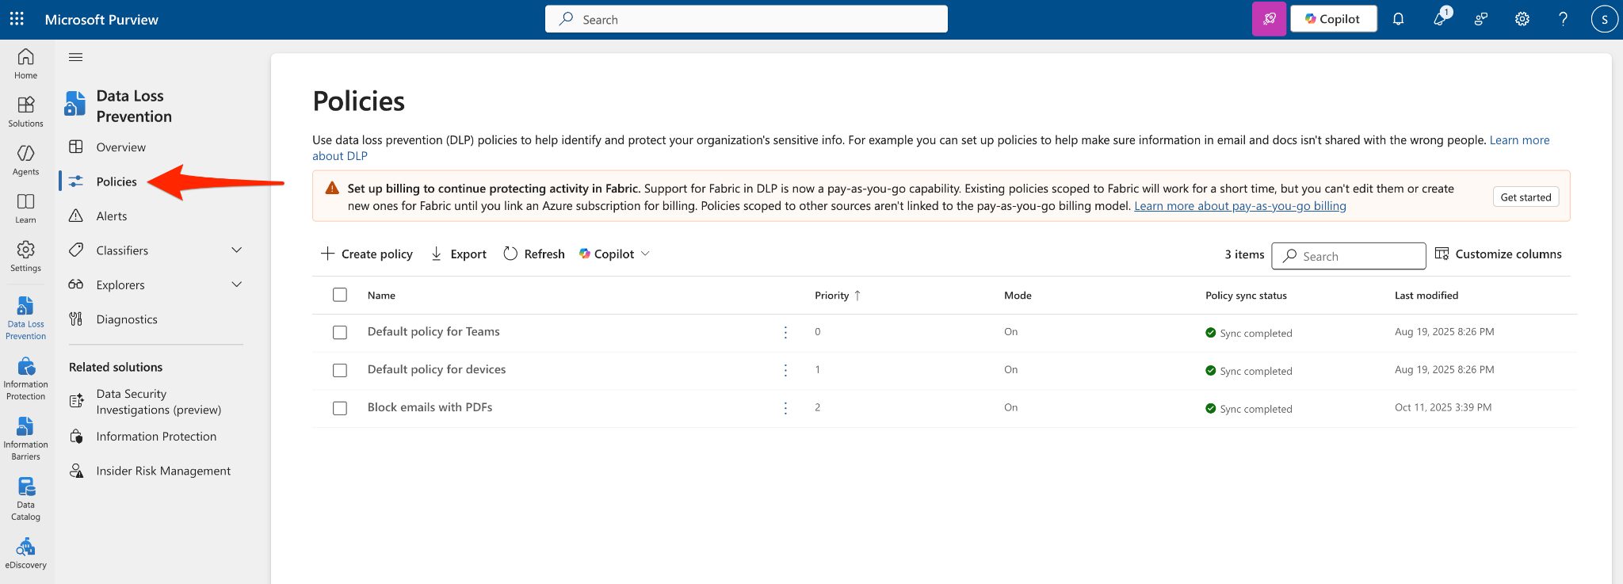

Modify Data Loss Prevention Policies
- This page will show all the policies that are configured in your tenant. Locate the DLP policy that tags sensitive information, select the policy and click the “Edit policy” button
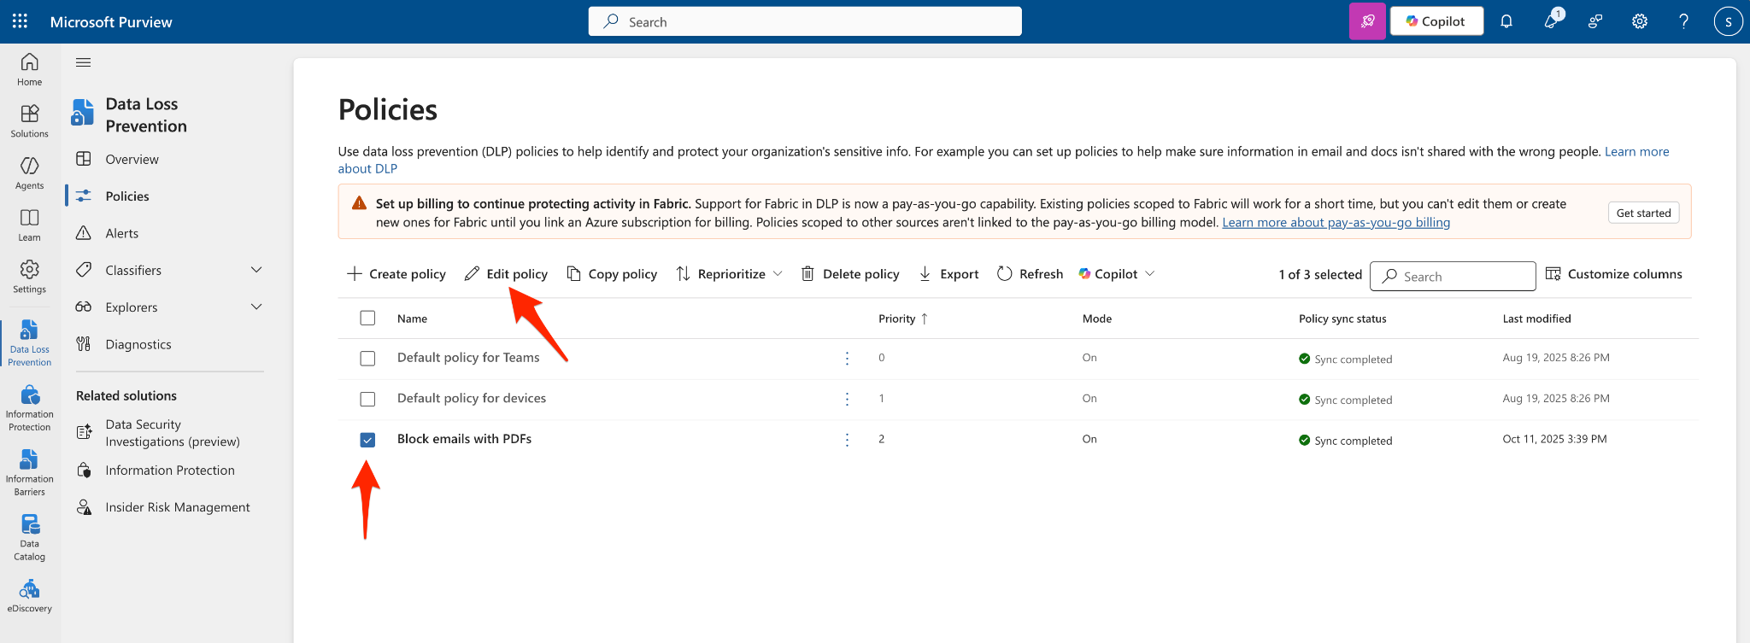

- On the DLP rules page, locate the rule you would like to modify and click on the pencil button to edit.
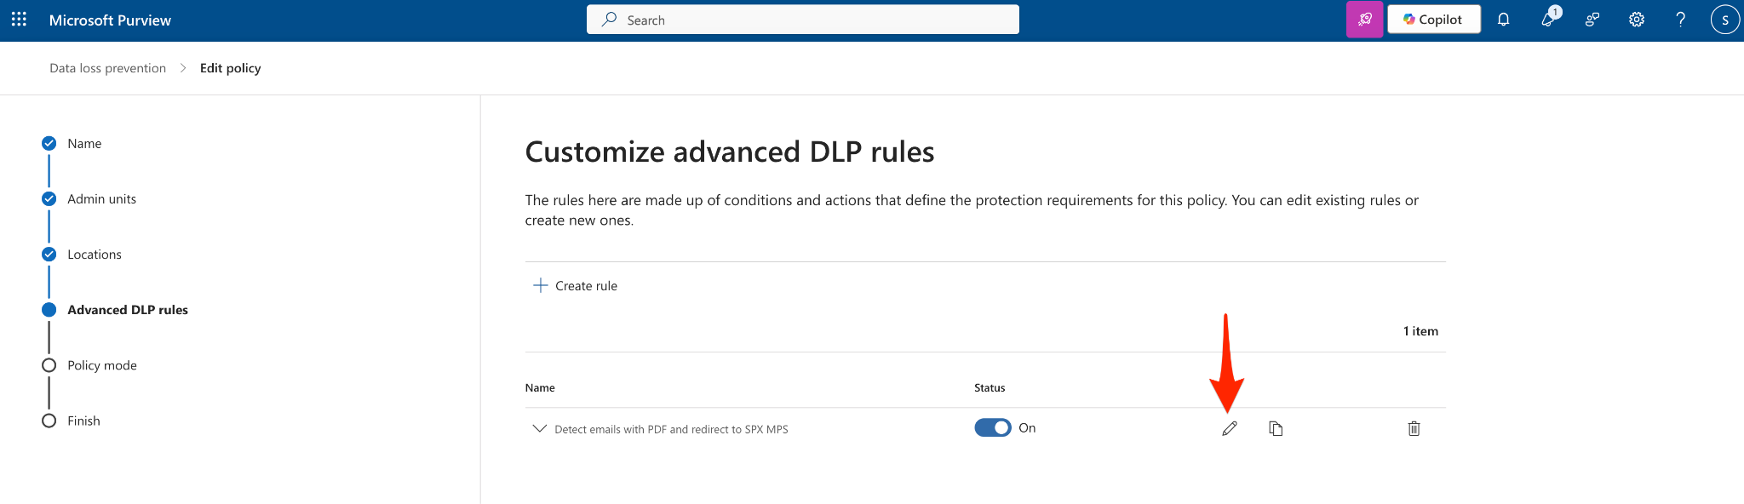

- Locate the “Actions” section and configure the following:
  - Add an action named “Set headers” - this action will add headers to the email.
  - Add the following header: X-DLP-RULE:<Detection Name>
    - The detection name can be used to match a detection to a specific SpecterX policy.
  - Add the following header: X-SPX-MPS:<Your SpecterX tenant ID>
  - Add an action named “Redirect the message to specific users” - this will redirect the email to SpecterX for protection.
  - Click on the “Add or remove users” button, and search for the contact we’ve previously created (SpecterX Mail Protection Service).
  - Enable or disable user notifications based on the organization’s needs.

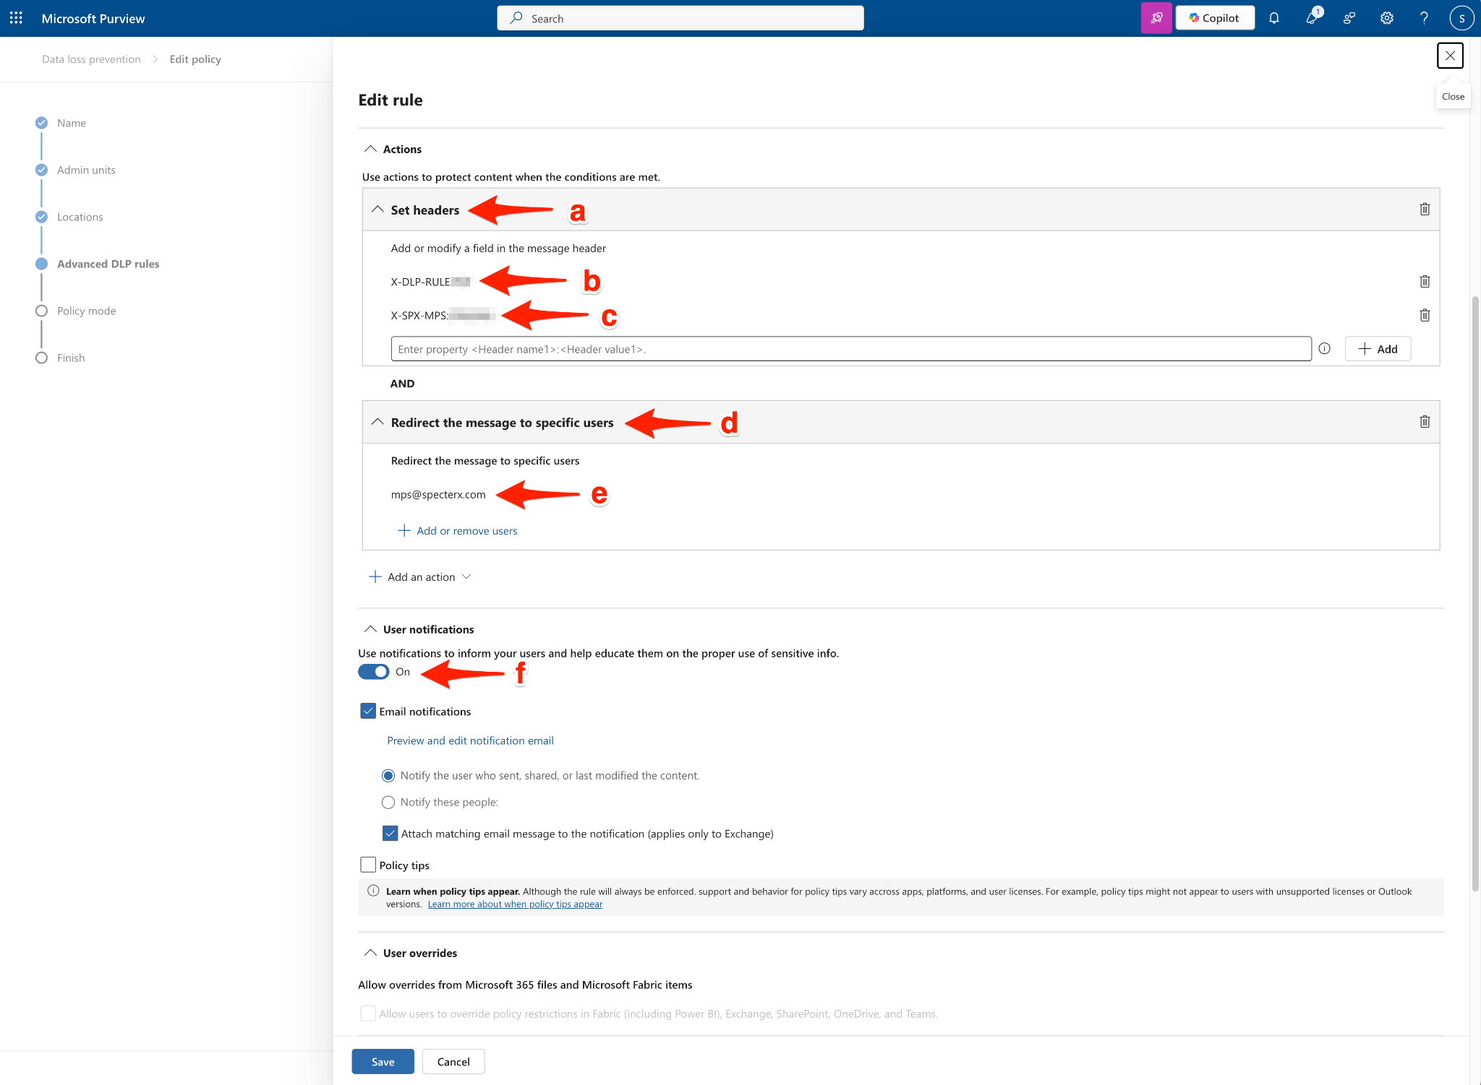

⚠️ Note: Please note that this configuration replaces the hosted quarantine configuration. Instead of quarantining the email, the email will be redirected to SpecterX to be protected and delivered to the external recipient.

- Save the configuration, and repeat for any policy that you would like to integrate with SpecterX.

With this configuration completed, your organization is now equipped to leverage Microsoft Purview’s classification engine in conjunction with SpecterX Mail Protection. Emails containing sensitive or regulated information will be automatically identified and securely redirected to SpecterX for protection, logging, and delivery. This integration not only enhances compliance but also provides real-time visibility and control over outbound data. Should you require any assistance or further clarification, please contact the SpecterX support team at support@specterx.com

